10 Essential Elements for Effective Facebook Branding

Whether you're just getting started on Facebook or want to fine tune your Page, follow these ten essential elements for Facebook Page branding to impress your customers and help give yourself a competitive advantage over the competition.

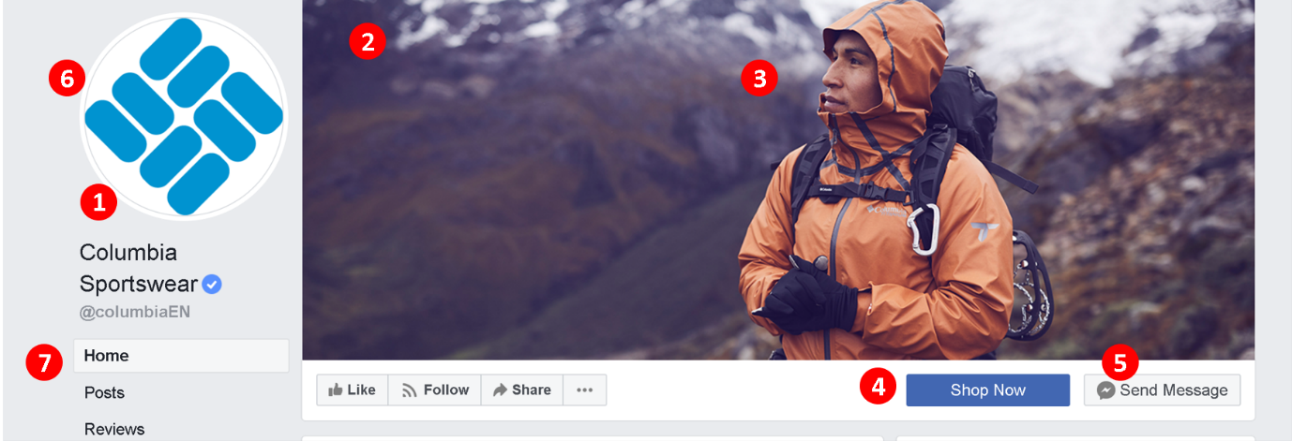

- Optimised Page name and URL: Choose a Page name that accurately reflects your brand. Add supplemental keyword descriptors to it if there is likely to be any confusion between you and anyone else, or just to help your page get found in search, e.g. “John’s Window Cleaning Boston | Gutters and Facias . Also grab a simple-to-read custom URL, e.g. facebook.com/windowcleaningboston URL on your website and marketing material.
- Optimised cover photo size: The perfect size for a Facebook cover photo is 851 x 315 pixels. Design yours within these constraints to make sure it is optimised for all displays.

- Great cover photo branding: Use the significant real estate of the cover photo to make an impact on people who visit your Page - to promote your latest offer, share your latest product range, or just a simple image (as above) that encapsulates what your brand is all about. Don’t forget to use the image’s description text to elaborate on the image, and even include a call-to-action and link if you need to.

- Add a call-to-action button: All Facebook Pages have the option to add a call-to-action button beneath their cover photo, and it’s a quick and easy way to drive traffic for whatever purpose you desire – to your online store, to sign up to your newsletter, to sell tickets to an event, etc.

- Get Messenger-ready: With customers’ phones and phone use dominated by chat apps, Facebook Messenger offers a quick and trustworthy method for brands to be available to converse with them. You don’t need to be available to answer queries instantly (set expectations within the Instant Replies option found in the Messaging section of your Facebook Page Settings), but do seriously consider it as a customer service channel.

- Optimised profile photo: The profile photo you use will represent you and your brand on Facebook whenever you post or comment, so making it clear and simple to identify at different sizes is crucial. Design it within a circle that is at least 180 x 180 pixels in size (preferably bigger) for the best results, and like with the cover photo, use its description to promote your brand to anyone who happens to click on it for a closer look.

- Re-order sections: Facebook allows you to re-order the different sections of your Page (Shop, Videos, Events, etc.); a way to display the content you want your audience to see at the top of your Page. In the Templates and Tabs section of Facebook Settings, click and drag a tab name to rearrange the order.

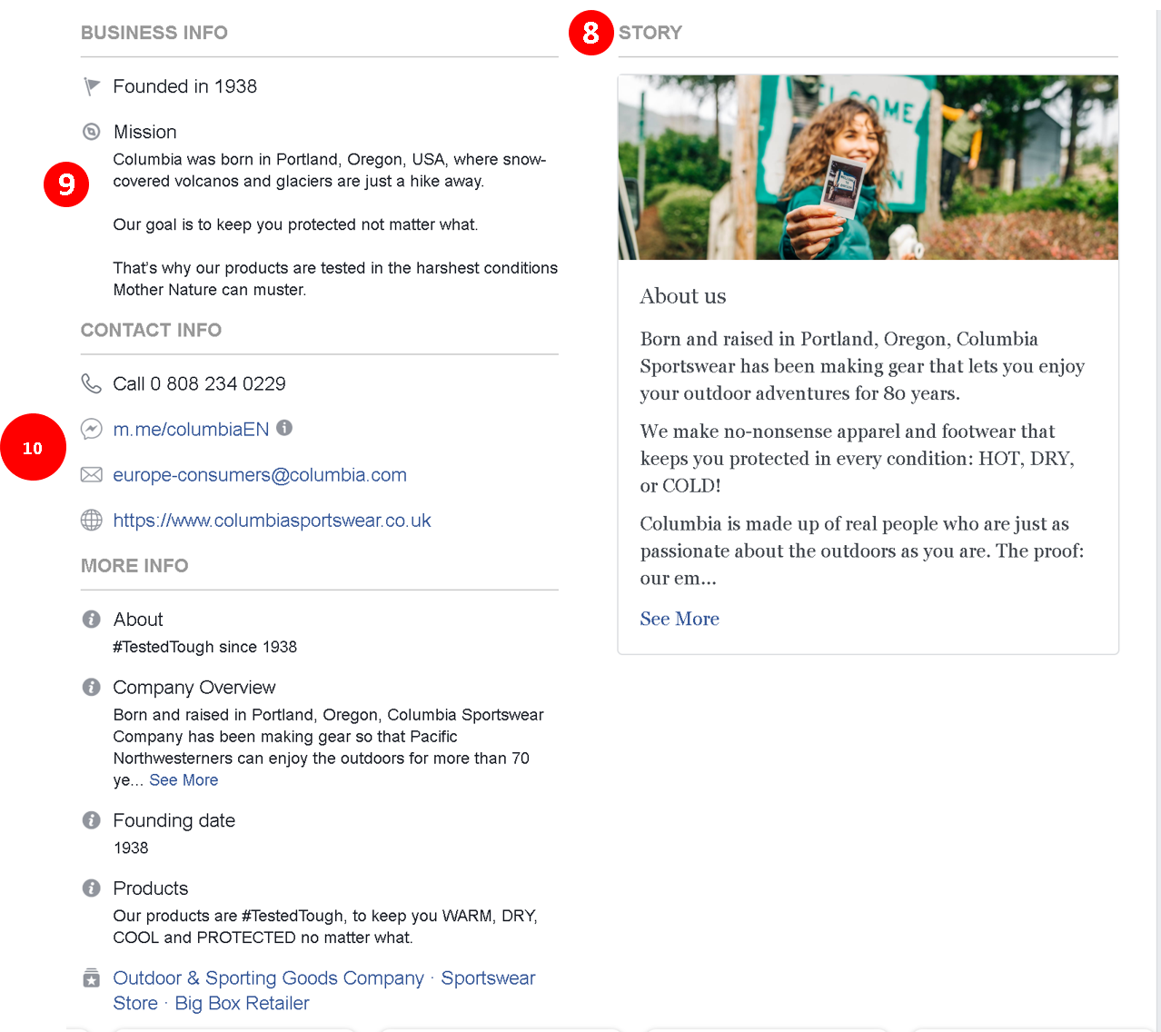

- Add your Our Story: The Our Story section is located prominently on the right side of your Facebook Page on desktop, or under the Home and About tabs when viewing on mobile. It gives you an opportunity to share another photo plus a more personal, and long form glimpse into your business. Check out Columbia’s Our Story above for a good example. For the photo, you might want to feature members of your team to help humanise your brand. If you’re going to use a call-to-action, add it before the “See More…” link so that more people will see it.
- And 10. It almost goes without saying that you should fill in your Facebook Page’s About and contact section as thoroughly as possible. If people want to know more about your business or to contact you, often they will turn straight to Facebook instead of hunting down your website on Google. And if they don’t find the information they want on Facebook, there’s a chance they might jump straight to a competitor.

